Problem Description:
Classification is the problem of identifying to which of a set of categories (sub-populations) a new observation belongs on the basis of a training set of data containing observations (or instances) whose category membership is known.

Dataset:
- 3_class_scene_image dataset

Classifier To Build:
  - Build Bayes classifier using Gaussian mixture model (GMM) with 1, 2, 4 and
8 mixtures on the reduced dimensional representations of data-set2 obtained
using PCA.
  - Build Bayes classifier using the density estimated from K-nearest neighbour (KNN) method
  - Fisher linear discriminant analysis (FDA) on given 3_class_scene_image. Use Bayes classifier using both unimodal Gaussian and GMM.
  - Perceptron-based classifier
  - Logistic regression classifier
  - SVM-based classifier using (a) linear kernel, (b) polynomial kernel and (c) Gaussian/RBF kernel

Solution Approach:
- Principle Components Analysis:
Principal component analysis (PCA) is a statistical procedure that uses an orthogonal transformation to convert a set of observations of possibly correlated variables (entities, each of which takes on various numerical values) into a set of values of linearly uncorrelated variables called principal components.

Procedure:
- Take all the training examples of all the classes.
- Compute the co-variance matrix.
- Perform eigen analysis to obtain d eigenvalues and corresponding eigenvectors where d is the dimension of one feature vector.
- Choose L eigen vectors corresponding to the L leading eigen values where L is the number of dimensions in which we our data is reduced to from d dimensions.
- Project each of the data points (training as well as test) onto these L eigenvectors to obtain the L principal components.
After reducing the dimension of the 32-dimensional BoVW representation of our images, GMM based classifications was carried out on the reduced dimensional dataset. We have carried out the GMM based classification for 1; 2; 4; 8 mixture components.

Results:
- Principle Component Analysis
- Variation Of Eigen Values
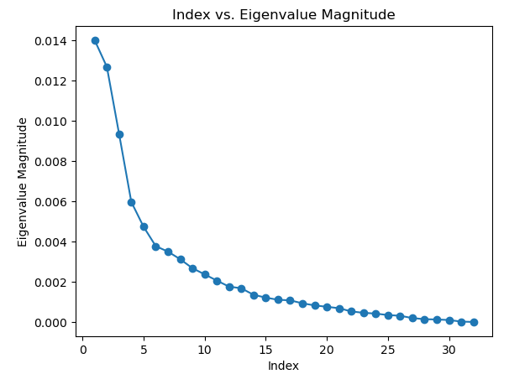

Figure 1: Variation of Eigenvalues

We observe that around 5 - 20 eigenvalues represent almost 95 percent of variation
in our data, while other eigenvalues don't contribute much. We take the most
significant L eigen vectors corresponding to the most significant L eigen values.
The values of L considered are 2, 5, 10, 15, 21.
- 3.2 Confusion Matrix, Precision, Recall and F-measure
- Where Class1 -botanical_garden, Class2 -bus_interior and Class3 -elevator_shaft
- Confusion Matrix and Analysis: When L = 1, M = 1
Actual  Predicted Class1 Class2 Class3  Class1 34 16 0  Class2 12 32 6  Class3 13 36 1  Table 1:Confusion Matrix | Class1 Class2 Class3  Precision 0.5762 0.3809 0.1428  Recall 0.68 0.64 0.02  F-Measure 0.6238 0.4776 0.0350  Table 2:Analysis

Accuracy | 44.66%
Mean Precision | 0.3666
Mean Recall | 0.4466
Mean F-Measure | 0.3788
Table 3:Result
- Misclassified Images:
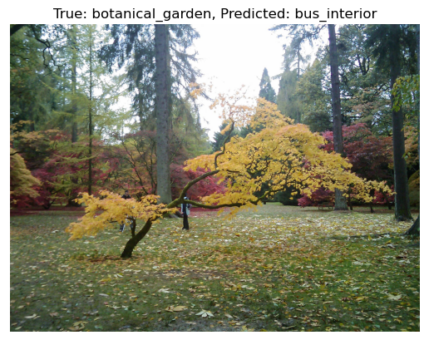
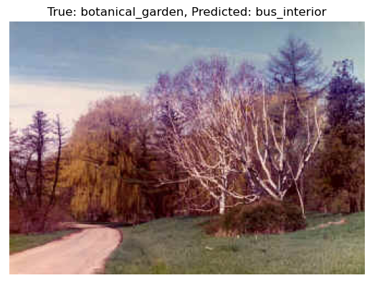
- Confusion Matrix and Analysis: When L = 1, M = 2
Actual  Predicted Class1 Class2 Class3  Class1 30 11 9  Class2 8 27 15  Class3 11 27 12  Table 4:Confusion Matrix | Class1 Class2 Class3  Precision 0.6122 0.4153 0.3333  Recall 0.60 0.54 0.24  F-Measure 0.6060 0.4695 0.2790  Table 5:Analysis

Accuracy | 46.00%
Mean Precision | 0.4536
Mean Recall | 0.46
Mean F-Measure | 0.4515
Table 6:Result
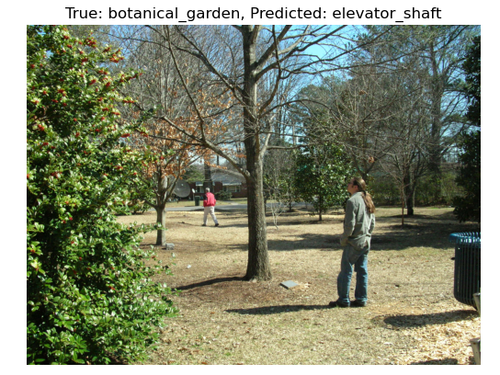
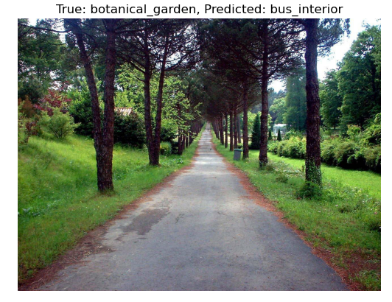
- Misclassified Images:

- Confusion Matrix and Analysis: When L = 1, M = 4

Actual  Predicted Class1 Class2 Class3  Class1 30 7 13  Class2 9 18 23  Class3 11 19 20  Table 7:Confusion Matrix | Class1 Class2 Class3  Precision 0.6 0.4090 0.3571  Recall 0.6 0.36 0.4  F-Measure 0.6 0.3829 0.3773  Table 8:Analysis

Accuracy | 45.33%
Mean Precision | 0.4554
Mean Recall | 0.4533
Mean F-Measure | 0.4534
Table 9:Result
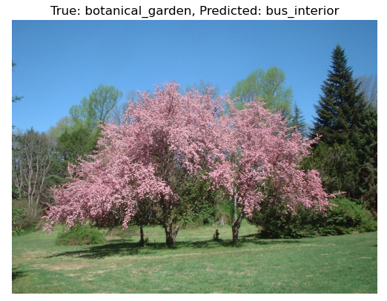
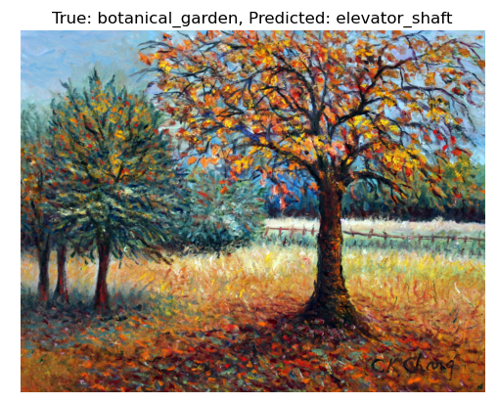
- Misclassified Images:

- Confusion Matrix and Analysis: When L = 1, M = 8
Actual  Predicted Class1 Class2 Class3  Class1 23 13 14  Class2 6 25 19  Class3 10 21 19  Table 10:Confusion Matrix | Class1 Class2 Class3  Precision 0.6154 0.6122 0.7222  Recall 0.8000 0.6000 0.5200  F-Measure 0.6957 0.6061 0.6047  Table 11:Analysis

Accuracy | 44.66%
Mean Precision | 0.4596
Mean Recall | 0.4466
Mean F-Measure | 0.4493
Table 12:Result
- Confusion Matrix and Analysis: When L = 2, M = 1
Actual  Predicted Class1 Class2 Class3  Class1 40 7 3  Class2 6 34 10  Class3 4 23 23  Table 13:Confusion Matrix | Class1 Class2 Class3  Precision 0.8 0.5312 0.6388  Recall 0.8 0.68 0.46  F-Measure 0.8 0.5964 0.5348  Table 14:Analysis

Accuracy | 64.66%
Mean Precision | 0.6567
Mean Recall | 0.6466
Mean F-Measure | 0.6437
Table 15:Result
- Confusion Matrix and Analysis: When L = 2, M = 2
Actual  Predicted Class1 Class2 Class3  Class1 33 10 7  Class2 5 33 12  Class3 3 24 23  Table 16:Confusion Matrix | Class1 Class2 Class3  Precision 0.8048 0.4925 0.5467  Recall 0.66 0.66 0.46  F-Measure 0.7252 0.5641 0.5  Table 17:Analysis

Accuracy | 59.33%
Mean Precision | 0.6150
Mean Recall | 0.5933
Mean F-Measure | 0.5964
Table 18:Result
- Confusion Matrix and Analysis: When L = 2, M = 4
Actual  Predicted Class1 Class2 Class3  Class1 31 12 7  Class2 5 33 12  Class3 4 22 24  Table 19:Confusion Matrix | Class1 Class2 Class3  Precision 0.775 0.4925 0.5581  Recall 0.62 0.66 0.48  F-Measure 0.6889 0.5641 0.5161  Table 20:Analysis

Accuracy | 58.67%
Mean Precision | 0.6085
Mean Recall | 0.5867
Mean F-Measure | 0.5897
Table21:Result
- Confusion Matrix and Analysis: When L = 2, M = 8
Actual  Predicted Class1 Class2 Class3  Class1 35 9 6  Class2 11 28 11  Class3 7 12 31  Table 22:Confusion Matrix | Class1 Class2 Class3  Precision 0.6603 0.5714 0.6458  Recall 0.7 0.56 0.62  F-Measure 0.6796 0.5656 0.6326  Table 23:Analysis

Accuracy | 62.66%
Mean Precision | 0.6258
Mean Recall | 0.6266
Mean F-Measure | 0.6259
Table 24:Result
- Confusion Matrix and Analysis: When L = 5, M = 1
Actual  Predicted Class1 Class2 Class3  Class1 43 4 3  Class2 1 40 9  Class3 3 18 29  Table 25:Confusion Matrix | Class1 Class2 Class3  Precision 0.9148 0.6451 0.7073  Recall 0.86 0.8 0.58  F-Measure 0.8865 0.7142 0.6373  Table 26:Analysis

Accuracy | 74.67%
Mean Precision | 0.7557
Mean Recall | 0.7466
Mean F-Measure | 0.7460
Table 27:Result
- Confusion Matrix and Analysis: When L = 5, M = 2
Actual  Predicted Class1 Class2 Class3  Class1 39 7 4  Class2 6 28 16  Class3 4 20 26  Table 28:Confusion Matrix | Class1 Class2 Class3  Precision 0.7959 0.5090 0.5652  Recall 0.78 0.56 0.52  F-Measure 0.7878 0.5333 0.5416  Table 29:Analysis

Accuracy | 62.00%
Mean Precision | 0.6234
Mean Recall | 0.62
Mean F-Measure | 0.6209
Table 30:Result
- Confusion Matrix and Analysis: When L = 5, M = 4
Actual  Predicted Class1 Class2 Class3  Class1 37 2 11  Class2 7 22 21  Class3 4 12 34  Table 31:Confusion Matrix | Class1 Class2 Class3  Precision 0.7708 0.6111 0.5151  Recall 0.74 0.44 0.68  F-Measure 0.7551 0.5116 0.5862  Table 31:Analysis

Accuracy | 62.00%
Mean Precision | 0.6323
Mean Recall | 0.62
Mean F-Measure | 0.6176
Table 32:Result
- Confusion Matrix and Analysis: When L = 5, M = 8
Actual  Predicted Class1 Class2 Class3  Class1 43 3 4  Class2 19 23 8  Class3 22 14 14  Table 33:Confusion Matrix | Class1 Class2 Class3  Precision 0.5119 0.575 0.5384  Recall 0.86 0.46 0.28  F-Measure 0.6417 0.5111 0.3684  Table 34:Analysis

Accuracy | 53.33%
Mean Precision | 0.5417
Mean Recall | 0.5333
Mean F-Measure | 0.5071
Table 35:Result
- Confusion Matrix and Analysis: When L = 10, M = 1
Actual  Predicted Class1 Class2 Class3  Class1 39 9 2  Class2 6 33 11  Class3 6 17 27  Table 36:Confusion Matrix | Class1 Class2 Class3  Precision 0.7647 0.5593 0.675  Recall 0.78 0.66 0.54  F-Measure 0.7722 0.6055 0.6  Table 37:Analysis

Accuracy | 66.00%
Mean Precision | 0.6663
Mean Recall | 0.66
Mean F-Measure | 0.6592
Table 38:Result
- Confusion Matrix and Analysis: When L = 10, M = 2
Actual  Predicted Class1 Class2 Class3  Class1 39 10 1  Class2 5 32 13  Class3 7 24 19  Table 39:Confusion Matrix | Class1 Class2 Class3  Precision 0.7647 0.4848 0.5757  Recall 0.78 0.64 0.38  F-Measure 0.7722 0.5517 0.4578  Table 40:Analysis

Accuracy | 60.00%
Mean Precision | 0.6048
Mean Recall | 0.6
Mean F-Measure | 0.5939
Table 41:Result

- Confusion Matrix and Analysis: When L = 10, M = 4
Actual  Predicted Class1 Class2 Class3  Class1 35 13 2  Class2 15 24 11  Class3 16 19 15  Table 42:Confusion Matrix | Class1 Class2 Class3  Precision 0.5303 0.4285 0.5357  Recall 0.7 0.48 0.3  F-Measure 0.6034 0.4528 0.3846  Table 43:Analysis

Accuracy | 49.33%
Mean Precision | 0.4981
Mean Recall | 0.4933
Mean F-Measure | 0.4802
Table 44:Result
- Confusion Matrix and Analysis: When L = 10, M = 8
Actual  Predicted Class1 Class2 Class3  Class1 16 6 28  Class2 3 8 39  Class3 1 8 41  Table 45:Confusion Matrix | Class1 Class2 Class3  Precision 0.6154 0.6122 0.7222  Recall 0.8000 0.6000 0.5200  F-Measure 0.6957 0.6061 0.6047  Table 46:Analysis

Accuracy | 43.33%
Mean Precision | 0.5144
Mean Recall | 0.4333
Mean F-Measure | 0.3994
Table 47:Result
- Confusion Matrix and Analysis: When L = 15, M = 1
Actual  Predicted Class1 Class2 Class3  Class1 43 5 2  Class2 7 31 12  Class3 5 16 29  Table 48:Confusion Matrix | Class1 Class2 Class3  Precision 0.7818 0.5961 0.6744  Recall 0.86 0.62 0.58  F-Measure 0.8190 0.6078 0.6236  Table 49:Analysis

Accuracy | 68.66%
Mean Precision | 0.6841
Mean Recall | 0.6866
Mean F-Measure | 0.6835
Table 50:Result
- Confusion Matrix and Analysis: When L = 15, M = 2
Actual  Predicted Class1 Class2 Class3  Class1 47 2 1  Class2 9 24 17  Class3 7 15 28  Table 51:Confusion Matrix | Class1 Class2 Class3  Precision 0.7460 0.5853 0.6086  Recall 0.94 0.48 0.56  F-Measure 0.8318 0.5274 0.5833  Table 552:Analysis

Accuracy | 66.00%
Mean Precision | 0.6466
Mean Recall | 0.66
Mean F-Measure | 0.6475
Table 53:Result
- Confusion Matrix and Analysis: When L = 15, M = 4
Actual  Predicted Class1 Class2 Class3  Class1 33 6 11  Class2 5 35 10  Class3 1 24 25  Table 54:Confusion Matrix | Class1 Class2 Class3  Precision 0.8461 0.5384 0.5434  Recall 0.66 0.7 0.5  F-Measure 0.7415 0.6086 0.5208  Table 55:Analysis

Accuracy | 62.00%
Mean Precision | 0.6426
Mean Recall | 0.62
Mean F-Measure | 0.6237
Table 56:Result
- Confusion Matrix and Analysis: When L = 15, M = 8
Actual  Predicted Class1 Class2 Class3  Class1 45 4 1  Class2 20 23 7  Class3 13 10 27  Table 57:Confusion Matrix | Class1 Class2 Class3  Precision 0.5769 0.6216 0.7714  Recall 0.9 0.46 0.54  F-Measure 0.7031 0.5287 0.6352  Table 58:Analysis

Accuracy | 63.33%
Mean Precision | 0.6566
Mean Recall | 0.6333
Mean F-Measure | 0.6223
Table 59:Result
- Confusion Matrix and Analysis: When L = 20, M = 1
Actual  Predicted Class1 Class2 Class3  Class1 42 5 3  Class2 7 31 12  Class3 5 15 30  Table 60:Confusion Matrix | Class1 Class2 Class3  Precision 0.7777 0.6078 0.6667  Recall 0.84 0.62 0.6  F-Measure 0.8076 0.6138 0.6315  Table 61:Analysis

Accuracy | 68.66%
Mean Precision | 0.6840
Mean Recall | 0.6866
Mean F-Measure | 0.6843
Table 62:Result
- Confusion Matrix and Analysis: When L = 20, M = 2
Actual  Predicted Class1 Class2 Class3  Class1 42 7 1  Class2 6 27 17  Class3 6 17 27  Table 63:Confusion Matrix | Class1 Class2 Class3  Precision 0.7778 0.5294 0.6  Recall 0.84 0.54 0.54  F-Measure 0.8076 0.5346 0.5684  Table 64:Analysis

Accuracy | 64.00%
Mean Precision | 0.6357
Mean Recall | 0.64
Mean F-Measure | 0.6369
Table 65:Result
- Confusion Matrix and Analysis: When L = 20, M = 4
Actual  Predicted Class1 Class2 Class3  Class1 11 1 38  Class2 1 4 45  Class3 0 4 46  Table 66:Confusion Matrix | Class1 Class2 Class3  Precision 0.9166 0.4444 0.3567  Recall 0.22 0.08 0.92  F-Measure 0.3548 0.1355 0.5139  Table 67:Analysis

Accuracy | 40.67%
Mean Precision | 0.5725
Mean Recall | 0.4067
Mean F-Measure | 0.3347
Table 68:Result

- Confusion Matrix and Analysis: When L = 20, M = 8
Actual  Predicted Class1 Class2 Class3  Class1 46 3 1  Class2 12 32 6  Class3 13 23 14  Table 69:Confusion Matrix | Class1 Class2 Class3  Precision 0.6478 0.5517 0.6667  Recall 0.92 0.64 0.28  F-Measure 0.7603 0.5925 0.3943  Table 70:Analysis

Accuracy | 61.33%
Mean Precision | 0.6220
Mean Recall | 0.6133
Mean F-Measure | 0.5824
Table 71:Result

3 Solution Approach
- Density estimated from K-nearest neighbour (KNN) method:
The K-Nearest Neighbor (KNN) method for density estimation is a non-parametric technique used to estimate the probability density of a given point in a dataset. Unlike parametric methods, KNN does not assume a specific functional form (e.g., Gaussian) for the data distribution, making it flexible for estimating densities in complex datasets.

Procedure:
- A region with many data points (high density) will have neighbors closer to $x$, leading to a higher density estimate.
- A region with few data points (low density) will have neighbors farther from $x$, resulting in a lower density estimate.
- Compute the distance of $x$ from every point in the dataset using a distance metric (e.g., Euclidean distance):
$$d\left(x,x_{i}\right)=\sqrt{\sum_{j=1}^{d}{{\left(x_{j}-x_{ij}\right)}^{2}}}$$

3.1 Results
1. Confusion Matrix and Analysis: when K=1
Actual  Predicted Class1 Class2 Class3  Class1 31 10 9  Class2 6 30 14  Class3 4 19 27  Table 72:Confusion Matrix | Class1 Class2 Class3  Precision 0.7560 0.5084 0.54  Recall 0.62 0.6 0.54  F-Measure 0.6813 0.5504 0.54  Table73:Analysis

Accuracy | 58.67%
Mean Precision | 0.6015
Mean Recall | 0.5866
Mean F-Measure | 0.5905
Table 74:Result
2. Confusion Matrix and Analysis: when K=3
Actual  Predicted Class1 Class2 Class3  Class1 32 8 10  Class2 3 31 16  Class3 1 17 32  Table 75:Confusion Matrix | Class1 Class2 Class3  Precision 0.8889 0.5535 0.5517  Recall 0.64 0.62 0.64  F-Measure 0.7441 0.5849 0.5925  Table 75:Analysis

Accuracy | 63.33%
Mean Precision | 0.6647
Mean Recall | 0.6333
Mean F-Measure | 0.6405
Table 76:Result
3. Confusion Matrix and Analysis: when K=5
Actual  Predicted Class1 Class2 Class3  Class1 33 8 9  Class2 3 31 16  Class3 1 15 34  Table 77:Confusion Matrix | Class1 Class2 Class3  Precision 0.8918 0.5740 0.5762  Recall 0.66 0.62 0.68  F-Measure 0.7586 0.5961 0.6238  Table 78:Analysis

Accuracy | 65.33%
Mean Precision | 0.6807
Mean Recall | 0.6533
Mean F-Measure | 0.6595
Table 79:Result
4. Confusion Matrix and Analysis: when K=7
Actual  Predicted Class1 Class2 Class3  Class1 34 6 10  Class2 3 29 18  Class3 1 15 34  Table 80:Confusion Matrix | Class1 Class2 Class3  Precision 0.8947 0.58 0.5483  Recall 0.68 0.58 0.68  F-Measure 0.7727 0.58 0.6071  Table81:Analysis

Accuracy | 64.66%
Mean Precision | 0.6743
Mean Recall | 0.6466
Mean F-Measure | 0.6732
Table 82:Result

Solution Approach
- Apply Fisher linear discriminant analysis (FDA)
Fisher Linear Discriminant Analysis (FDA) is a dimensionality reduction technique primarily used for supervised classification problems. It finds a linear combination of features that maximizes the separation between multiple classes by projecting high-dimensional data into a lower-dimensional space (often 1D or 2D).

Procedure:
- $A dataset with Nsamples, each represented as a ddd-dimensional vector xxx, along with class labels.$
- $Compute the within class scatter matrix S_{W}​and Compute the between-class scatter matrix S_{B}.$
- Solve the generalized eigenvalue problem:
$$S_{W}^{-1}S_{B}w=λw$$
- Select the eigenvectors corresponding to the $largest c-1 eigenvalues$.
- Project the original data $x$ onto the reduced space using the projection $matrix W formed$y the selected eigenvectors:
$$x^{'}=W^{T}x$$

4.1 Results
1. bayes Classifier using Unimodal Gaussian
Actual  Predicted Class1 Class2 Class3  Class1 41 4 5  Class2 2 35 13  Class3 1 19 30  Table 83:Confusion Matrix | Class1 Class2 Class3  Precision 0.9318 0.6034 0.625  Recall 0.82 0.7 0.6  F-Measure 0.8723 0.6481 0.6122  Table 84:Analysis

Accuracy | 70.66%
Mean Precision | 0.7200
Mean Recall | 0.7066
Mean F-Measure | 0.7109
Table 85:Result
2. bayes Classifier using Gaussian mixer model (GMM)
Actual  Predicted Class1 Class2 Class3  Class1 38 5 7  Class2 2 33 15  Class3 1 17 32  Table 86:Confusion Matrix | Class1 Class2 Class3  Precision 0.9268 0.6 0.5925  Recall 0.76 0.66 0.64  F-Measure 0.8351 0.6285 0.6153  Table 87:Analysis

Accuracy | 68.66%
Mean Precision | 0.7064
Mean Recall | 0.6866
Mean F-Measure | 0.6930
Table 88:Result

Solution Approach
- Perceptron Based Classifier

The Perceptron-based classifier is one of the simplest types of artificial neural networks. It is primarily used for binary classification and operates by finding a linear decision boundary that separates two classes. When extended to multi-class classification, strategies like One-vs-Rest or One-vs-One are used.

Procedure:
To extend the Perceptron to multi-class classification, the One-vs-Rest (OvR) approach is commonly used:
- Train a separate binary Perceptron for each class.
- Treat the current class as the positive class and all other classes as the negative class.
- Initialize one weight $vector w_{i} for each class i,wherei=1,…,c$ (for class classification).
- Initialize the corresponding bias terms $b_{i}$​ to 0.

5.1 Results
1. Multi-Class Perceptron Classifier
Actual  Predicted Class1 Class2 Class3  Class1 22 3 25  Class2 1 20 29  Class3 0 7 43  Table 89:Confusion Matrix | Class1 Class2 Class3  Precision 0.9556 0.6667 0.4432  Recall 0.44 0.4 0.86  F-Measure 0.6027 0.5 0.5850  Table 90:Analysis

Accuracy | 56.67%
Mean Precision | 0.6888
Mean Recall | 0.5667
Mean F-Measure | 0.7562
Table 91:Result

Solution Approach
- Logistic Regression Classifier

Logistic regression is a supervised learning algorithm primarily used for binary classification, although it can be extended to multi-class classification. It models the probability that a given input $x$ belongs to a particular class using a logistic function (sigmoid).

Procedure:
- A dataset with input feature vectors $x$ binary labels $y ∈\{0, 1\}$
- Initialize the weight vector $w$ and bias b to zeros or small random values.
- For each sample $x_{i}$ compute the linear combination zzz and apply the sigmoid function:
$$z_{i}=w⋅x_{i}+b, P\left(y=1 | x_{i}\right)=σ\left(z_{i}\right)$$
- Use the log-loss (negative log-likelihood) as the cost function:
$$L=-\frac{1}{n}\sum_{i=1}^{n}{\left[y_{i}\log\left(P\left(y=1 | x_{i}\right)\right)+\left(1-y_{i}\right)\log\left(1-P\left(y=1 | x_{i}\right)\right)\right]}$$
- Compute gradients of the loss with respect to w and b:
$$\frac{∂L}{∂w}=-\frac{1}{n}\sum_{i=1}^{n}{\left(y_{i}-P\left(y=1 | x_{i}\right)\right)x_{i}}$$
$$\frac{∂L}{∂b}=-\frac{1}{n}\sum_{i=1}^{n}{\left(y_{i}-P\left(y=1 | x_{i}\right)\right)}$$
- Update parameters:
$$w←w-η⋅\frac{∂L}{∂w}$$

$$b←b-η⋅\frac{∂L}{∂b}$$

6.1 Results
1. Multi-Class Logistic Regression Classifier
Actual  Predicted Class1 Class2 Class3  Class1 39 6 5  Class2 2 35 13  Class3 2 19 29  Table 92:Confusion Matrix | Class1 Class2 Class3  Precision 0.9069 0.5833 0.6170  Recall 0.78 0.7 0.58  F-Measure 0.8387 0.6363 0.5979  Table 93:Analysis

Accuracy | 68.67%
Mean Precision | 0.7024
Mean Recall | 0.6866
Mean F-Measure | 0.6910
Table 94:Result

Solution Approach
- SVM based Classifier

Support Vector Machines (SVM) are supervised learning algorithms used for classification and regression. They aim to find the optimal hyperplane that separates data points of different classes with the maximum margin. SVMs are versatile due to the use of kernel functions, enabling both linear and non-linear decision boundaries.

Procedure:
- The goal is to maximize the margin between the hyperplane and the nearest data points (support vectors).
- Minimize:
$$\frac{1}{2}{\left|\left|w\right|\right|}^{2}$$
- Subject to constraints:
$$y_{i}\left(w⋅x_{i}+b\right)≥1, ∀i$$
- Transform input features into a higher-dimensional space where a linear hyperplane can separate the data.
- Linear Kernel: Suitable for linearly separable data.
$$K\left(x_{i},x_{j}\right)=x_{i}⋅x_{j}$$
- Polynomial Kernel: Maps data into a higher polynomial feature space.
$$K\left(x_{i},x_{j}\right)={\left(x_{i}⋅x_{j}+r\right)}^{d}$$
- Gaussian/RBF Kernel: Useful for non-linear separable data.
$$K\left(x_{i},x_{j}\right)=\exp\left(-γ{\left|\left|x_{i}-x_{j}\right|\right|}^{2}\right)$$

7.1 Results
1. Linear Kernel: when C=0.1
Actual  Predicted Class1 Class2 Class3  Class1 27 20 3  Class2 3 38 9  Class3 3 26 21  Table 95:Confusion Matrix | Class1 Class2 Class3  Precision 0.8181 0.4523 0.6363  Recall 0.54 0.76 0.42  F-Measure 0.6506 0.5671 0.5060  Table 96:Analysis

Accuracy | 57.33%
Mean Precision | 0.6356
Mean Recall | 0.5733
Mean F-Measure | 0.5745
Table 97:Result
2. Linear Kernel: when C=1
Actual  Predicted Class1 Class2 Class3  Class1 31 10 9  Class2 1 37 12  Class3 1 22 27  Table 98:Confusion Matrix | Class1 Class2 Class3  Precision 0.9393 0.5362 0.5625  Recall 0.62 0.74 0.54  F-Measure 0.7469 0.6218 0.5510  Table 99:Analysis

Accuracy | 63.33%
Mean Precision | 0.6793
Mean Recall | 0.6333
Mean F-Measure | 0.6399
Table 100:Result
3. Linear Kernel: when C=10
Actual  Predicted Class1 Class2 Class3  Class1 38 5 7  Class2 2 37 11  Class3 1 18 31  Table 101:Confusion Matrix | Class1 Class2 Class3  Precision 0.9268 0.6166 0.6326  Recall 0.76 0.74 0.62  F-Measure 0.8351 0.6727 0.6262  Table 102:Analysis

Accuracy | 70.67%
Mean Precision | 0.7253
Mean Recall | 0.7066
Mean F-Measure | 0.7113
Table 103:Result
4. Polynomial Kernel: when C=0.1, Degree =2
Actual  Predicted Class1 Class2 Class3  Class1 33 12 5  Class2 1 42 7  Class3 1 25 24  Table 104:Confusion Matrix | Class1 Class2 Class3  Precision 0.9428 0.5316 0.6667  Recall 0.66 0.84 0.48  F-Measure 0.7764 0.6511 0.5581  Table 103:Analysis

Accuracy | 66.00%
Mean Precision | 0.7137
Mean Recall | 0.66
Mean F-Measure | 0.6619
Table 104:Result
5. Polynomial Kernel: when C=0.1, Degree =3
Actual  Predicted Class1 Class2 Class3  Class1 38 7 5  Class2 3 40 7  Class3 1 21 28  Table 105:Confusion Matrix | Class1 Class2 Class3  Precision 0.9047 0.5882 0.7067  Recall 0.76 0.8 0.56  F-Measure 0.8260 0.6779 0.6222  Table 106:Analysis

Accuracy | 70.67%
Mean Precision | 0.7309
Mean Recall | 0.7066
Mean F-Measure | 0.7087
Table 107:Result

6. Polynomial Kernel: when C=0.1, Degree =4
Actual  Predicted Class1 Class2 Class3  Class1 41 5 4  Class2 5 38 7  Class3 1 20 29  Table 108:Confusion Matrix | Class1 Class2 Class3  Precision 0.8723 0.6031 0.725  Recall 0.82 0.76 0.58  F-Measure 0.8453 0.6725 0.6444  Table 109:Analysis

Accuracy | 72.00%
Mean Precision | 0.7337
Mean Recall | 0.7200
Mean F-Measure | 0.7207
Table 110:Result

7. Polynomial Kernel: when C=1, Degree =2
Actual  Predicted Class1 Class2 Class3  Class1 41 5 4  Class2 4 38 8  Class3 1 18 31  Table 111:Confusion Matrix | Class1 Class2 Class3  Precision 0.8913 0.6229 0.7209  Recall 0.82 0.76 0.62  F-Measure 0.8541 0.6846 0.6667  Table 112:Analysis

Accuracy | 73.33%
Mean Precision | 0.7450
Mean Recall | 0.7333
Mean F-Measure | 0.7351
Table 113:Result
4. Polynomial Kernel: when C=1, Degree =3
Actual  Predicted Class1 Class2 Class3  Class1 43 3 4  Class2 6 37 7  Class3 2 18 30  Table 114:Confusion Matrix | Class1 Class2 Class3  Precision 0.8431 0.6379 0.7317  Recall 0.86 0.74 0.6  F-Measure 0.8514 0.6851 0.6593  Table 115:Analysis

Accuracy | 73.33%
Mean Precision | 0.7375
Mean Recall | 0.7333
Mean F-Measure | 0.7320
Table 116:Result
4. Polynomial Kernel: when C=1, Degree =4
Actual  Predicted Class1 Class2 Class3  Class1 41 4 5  Class2 5 38 7  Class3 4 17 29  Table 117:Confusion Matrix | Class1 Class2 Class3  Precision 0.82 0.6440 0.7073  Recall 0.82 0.76 0.58  F-Measure 0.82 0.6972 0.6373  Table 118:Analysis

Accuracy | 72.00%
Mean Precision | 0.7237
Mean Recall | 0.7200
Mean F-Measure | 0.7182
Table 119:Result
4. Polynomial Kernel: when C=10, Degree =2
Actual  Predicted Class1 Class2 Class3  Class1 41 4 5  Class2 5 35 10  Class3 2 18 30  Table 120:Confusion Matrix | Class1 Class2 Class3  Precision 0.8541 0.6140 0.6667  Recall 0.82 0.7 0.6  F-Measure 0.8367 0.6542 0.6315  Table 121:Analysis

Accuracy | 70.67%
Mean Precision | 0.7116
Mean Recall | 0.7067
Mean F-Measure | 0.7075
Table 123:Result
4. Polynomial Kernel: when C=10, Degree =3
Actual  Predicted Class1 Class2 Class3  Class1 40 4 6  Class2 7 37 6  Class3 4 19 27  Table 124:Confusion Matrix | Class1 Class2 Class3  Precision 0.7843 0.6166 0.6923  Recall 0.8 0.74 0.54  F-Measure 0.7920 0.6727 0.6067  Table 125:Analysis

Accuracy | 69.33%
Mean Precision | 0.6977
Mean Recall | 0.6933
Mean F-Measure | 0.6905
Table 126:Result
4. Polynomial Kernel: when C=10, Degree =4
Actual  Predicted Class1 Class2 Class3  Class1 39 5 6  Class2 7 35 8  Class3 5 12 33  Table 127:Confusion Matrix | Class1 Class2 Class3  Precision 0.7647 0.6730 0.7021  Recall 0.78 0.7 0.66  F-Measure 0.7722 0.6862 0.6804  Table 128:Analysis

Accuracy | 71.33%
Mean Precision | 0.7133
Mean Recall | 0.7133
Mean F-Measure | 0.7129
Table 129:Result
4. Gaussian/RBF Kernel: when C=0.1, Gamma =0.01
Actual  Predicted Class1 Class2 Class3  Class1 27 20 3  Class2 3 38 9  Class3 3 26 21  Table 130:Confusion Matrix | Class1 Class2 Class3  Precision 0.8181 0.4523 0.6363  Recall 0.54 0.76 0.42  F-Measure 0.6506 0.5671 0.5060  Table 131:Analysis

Accuracy | 57.33%
Mean Precision | 0.6356
Mean Recall | 0.5733
Mean F-Measure | 0.5745
Table 132:Result
4. Gaussian/RBF Kernel: when C=0.1, Gamma =0.1
Actual  Predicted Class1 Class2 Class3  Class1 27 20 3  Class2 2 40 8  Class3 3 26 21  Table 133:Confusion Matrix | Class1 Class2 Class3  Precision 0.8437 0.4651 0.6562  Recall 0.54 0.80 0.42  F-Measure 0.6585 0.5882 0.5121  Table 134:Analysis

Accuracy | 58.67%
Mean Precision | 0.6550
Mean Recall | 0.5866
Mean F-Measure | 0.5863
Table 135:Result
4. Gaussian/RBF Kernel: when C=0.1, Gamma =1
Actual  Predicted Class1 Class2 Class3  Class1 25 22 3  Class2 2 43 5  Class3 2 28 20  Table 136:Confusion Matrix | Class1 Class2 Class3  Precision 0.8620 0.4623 0.7142  Recall 0.5 0.86 0.4  F-Measure 0.6329 0.6013 0.5128  Table 137:Analysis

Accuracy | 58.67%
Mean Precision | 0.6795
Mean Recall | 0.5867
Mean F-Measure | 0.5823
Table 138:Result
4. Gaussian/RBF Kernel: when C=1, Gamma =0.01
Actual  Predicted Class1 Class2 Class3  Class1 27 20 3  Class2 3 38 9  Class3 3 26 21  Table 139:Confusion Matrix | Class1 Class2 Class3  Precision 0.8181 0.4523 0.6363  Recall 0.54 0.76 0.42  F-Measure 0.6506 0.5671 0.5060  Table 140:Analysis

Accuracy | 57.33%
Mean Precision | 0.6356
Mean Recall | 0.5733
Mean F-Measure | 0.5745
Table 141:Result
4. Gaussian/RBF Kernel: when C=1, Gamma =0.1
Actual  Predicted Class1 Class2 Class3  Class1 27 20 3  Class2 2 40 8  Class3 3 26 21  Table 142:Confusion Matrix | Class1 Class2 Class3  Precision 0.8437 0.4651 0.6562  Recall 0.54 0.80 0.42  F-Measure 0.6585 0.5882 0.5121  Table 143:Analysis

Accuracy | 58.67%
Mean Precision | 0.6550
Mean Recall | 0.5866
Mean F-Measure | 0.5863
Table 144:Result
4. Gaussian/RBF Kernel: when C=1, Gamma =1
Actual  Predicted Class1 Class2 Class3  Class1 36 10 4  Class2 1 42 7  Class3 1 22 27  Table 145:Confusion Matrix | Class1 Class2 Class3  Precision 0.9437 0.5675 0.7105  Recall 0.72 0.84 0.54  F-Measure 0.8181 0.6774 0.6136  Table 146:Analysis

Accuracy | 70.00%
Mean Precision | 0.7418
Mean Recall | 0.7000
Mean F-Measure | 0.7030
Table 147:Result
4. Gaussian/RBF Kernel: when C=10, Gamma =0.01
Actual  Predicted Class1 Class2 Class3  Class1 27 20 3  Class2 3 38 9  Class3 3 26 21  Table148:Confusion Matrix | Class1 Class2 Class3  Precision 0.8181 0.4523 0.6363  Recall 0.54 0.76 0.42  F-Measure 0.6506 0.5671 0.5060  Table 149:Analysis

Accuracy | 57.33%
Mean Precision | 0.6356
Mean Recall | 0.5733
Mean F-Measure | 0.5745
Table 150:Result
4. Gaussian/RBF Kernel: when C=10, Gamma =0.1
Actual  Predicted Class1 Class2 Class3  Class1 35 6 9  Class2 2 37 11  Class3 1 22 27  Table 151:Confusion Matrix | Class1 Class2 Class3  Precision 0.9210 0.5691 0.5744  Recall 0.7 0.74 0.54  F-Measure 0.7954 0.6434 0.5567  Table 152:Analysis

Accuracy | 66.00%
Mean Precision | 0.6882
Mean Recall | 0.66
Mean F-Measure | 0.6652
Table 153:Result
4. Gaussian/RBF Kernel: when C=10, Gamma =1
Actual  Predicted Class1 Class2 Class3  Class1 41 5 4  Class2 3 42 8  Class3 1 18 31  Table 154:Confusion Matrix | Class1 Class2 Class3  Precision 0.9111 0.6290 0.7209  Recall 0.70 0.78 0.62  F-Measure 0.7954 0.6434 0.5567  Table 155:Analysis

Accuracy | 74.00%
Mean Precision | 0.7536
Mean Recall | 0.7400
Mean F-Measure | 0.7420
Table 156:Result

